### 

### Semester One Examination, 2018

### Question/Answer booklet

# MATHEMATICS SPECIALIST

**UNIT 3**

## Section One:

## Calculator-free

Your Name_________________________________________

Your Teacher’s Name_________________________________

Time allowed for this section

Reading time before commencing work: five minutes

Working time: fifty minutes

## Materials required/recommended for this section

***To be provided by the supervisor***

This Question/Answer booklet

Formula sheet

***To be provided by the candidate***

Standard items: pens (blue/black preferred), pencils (including coloured), sharpener, correction fluid/tape, eraser, ruler, highlighters

Special items: nil

## Important note to candidates

No other items may be taken into the examination room. It is **your** responsibility to ensure that you do not have any nauthorized material. If you have any nauthorized material with you, hand it to the supervisor **before** reading any further.

|  |  |  |  |
| --- | --- | --- | --- |
| Question | Mark | Question | Mark |
| 1 |  | 5 |  |
| 2 |  | 6 |  |
| 3 |  | 7 |  |
| 4 |  | 8 |  |

**Structure of this paper**

|  |  |  |  |  |  |
| --- | --- | --- | --- | --- | --- |
| Section | Number of questions available | Number of questions to be answered | Working time (minutes) | Marks available | Percentage of examination |
| Section One:  Calculator-free | 8 | 8 | 50 | 50 | 35 |
| Section Two:  Calculator-assumed | 13 | 13 | 100 | 95 | 65 |
|  |  |  |  | **Total** | 100 |

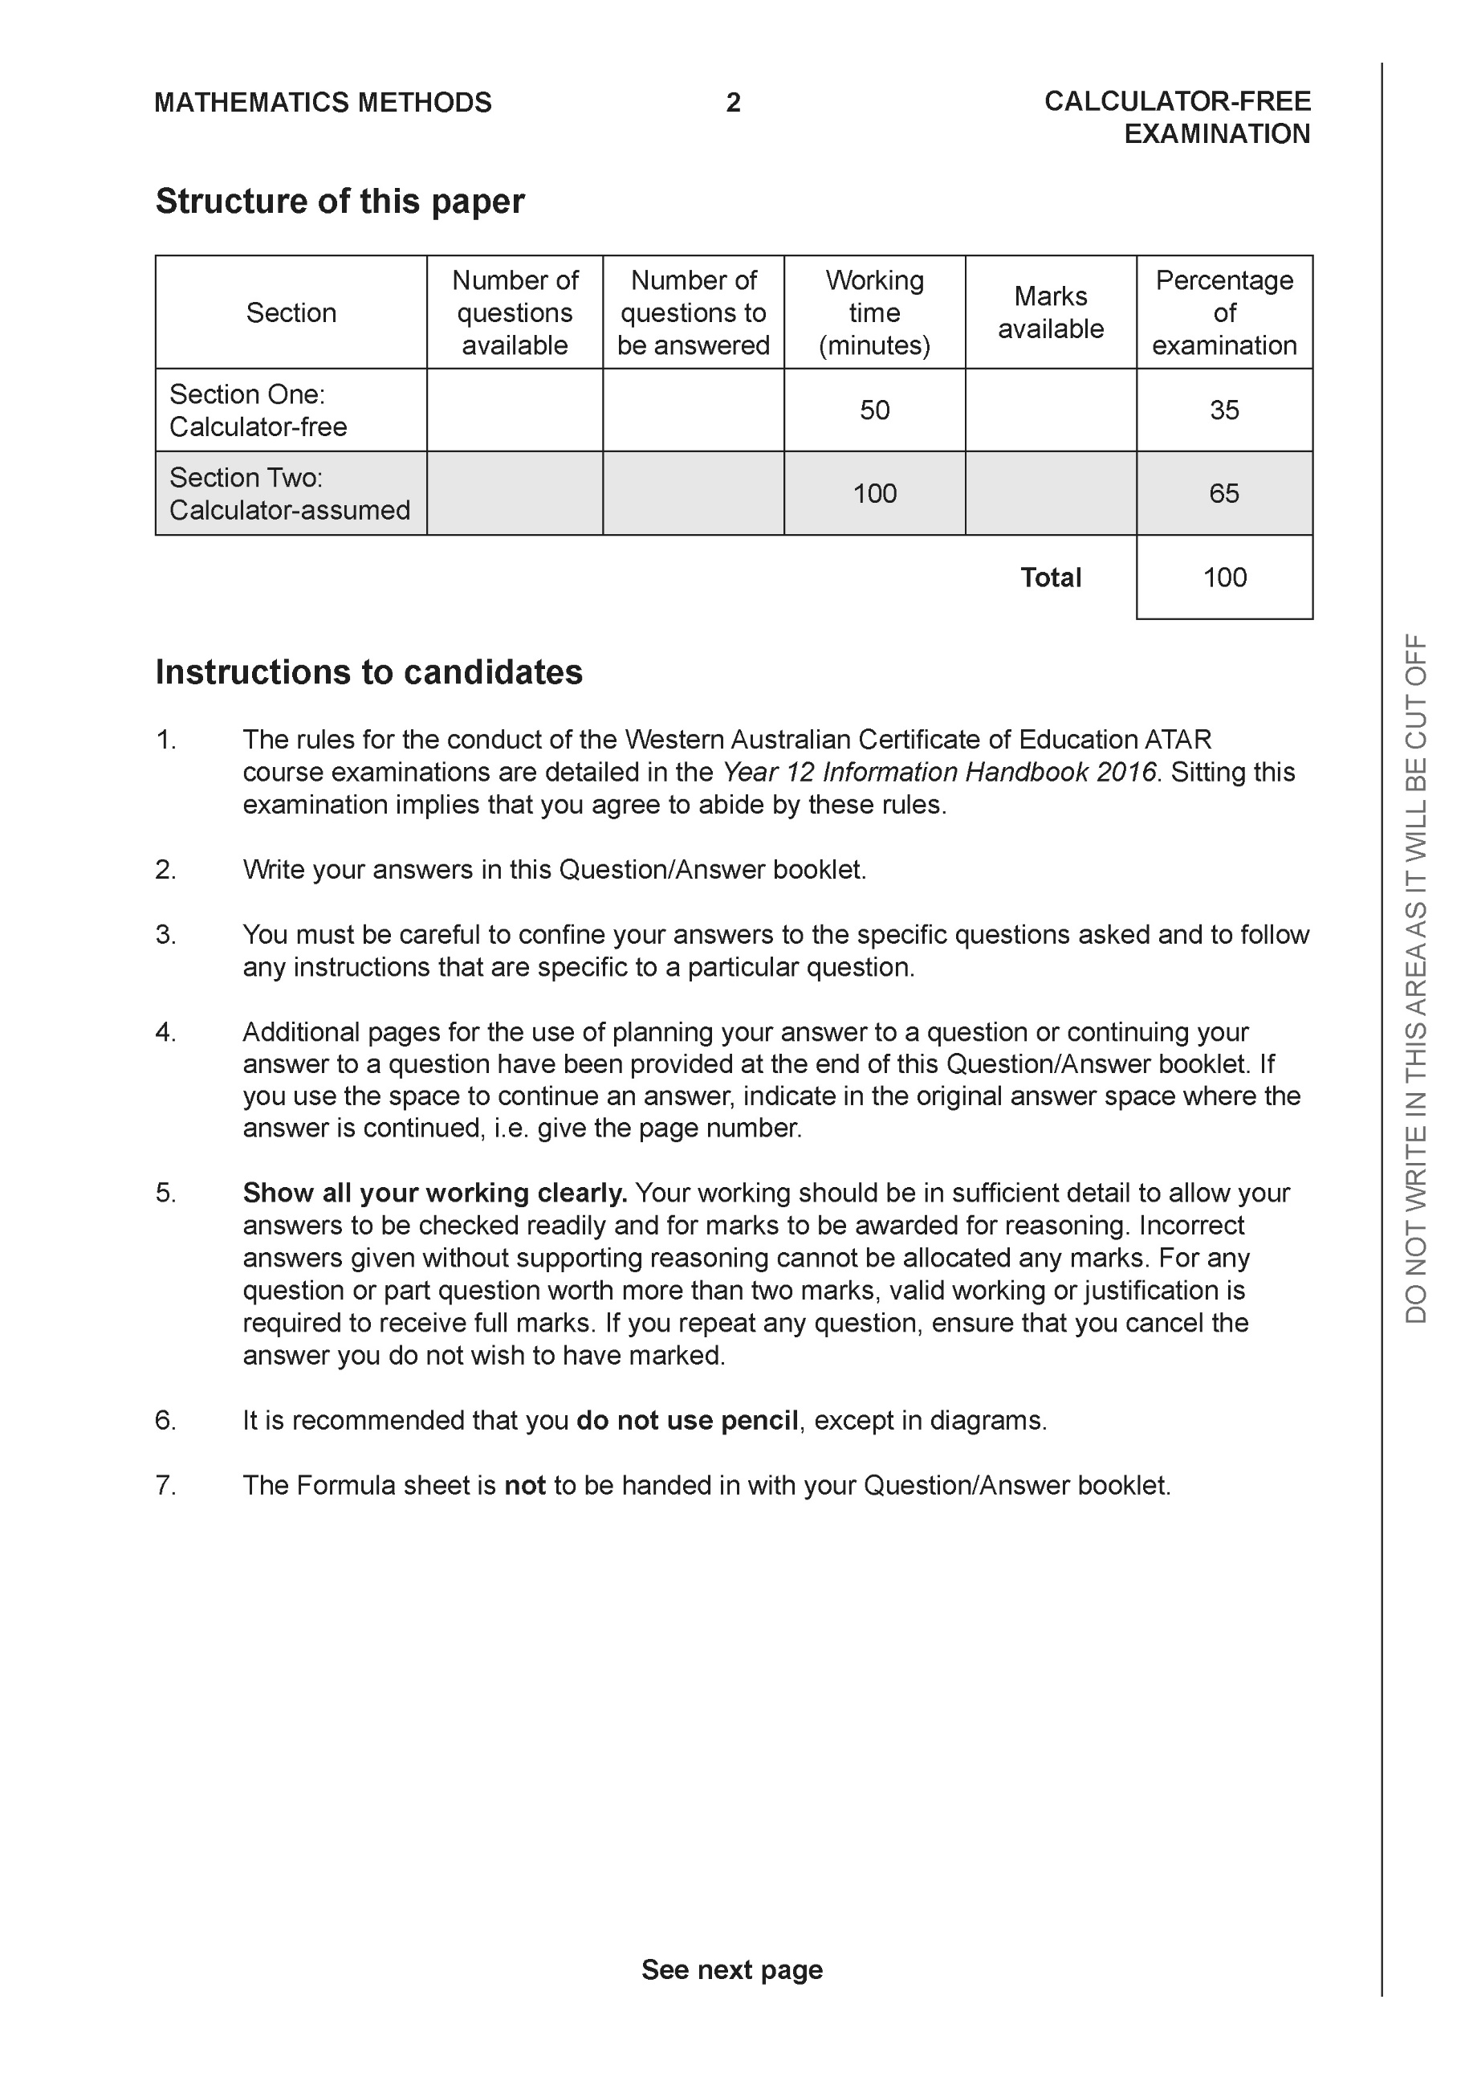

**Section One: Calculator-free (50 Marks)**

This section has **eight (8)** questions. Answer **all** questions. Write your answers in the spaces provided.

Spare pages are included at the end of this booklet. They can be used for planning your responses and/or as additional space if required to continue an answer.

● Planning: If you use the spare pages for planning, indicate this clearly at the top of the page.

● Continuing an answer: If you need to use the space to continue an answer, indicate in the original answer space where the answer is continued, i.e. give the page number. Fill in the number of the question that you are continuing to answer at the top of the page.

Working time: 50 minutes.

**Question 1 (8 marks)**

Consider the polynomial  where 

(a) Determine the roots of  and label them  (2 marks)

(b) Determine  (3 marks)

(c) Determine  (3 marks)

**Question 2 (7 marks)**

Let  where  are real numbers.

(a) Show that  (2 marks)

(b) The expression can be written in the form  , determine expressions for the real constants  in terms of . (3 marks)

(c) Given that the  and  , determine the . (2 marks)

**Question 3 (7 marks)**

Consider the following functions .

 

(a) State the natural domain and range of . (2 marks)

(b) State the natural domain and range of  (3 marks)

(c) Does  exist over the natural domain of ? Explain. (2 marks)

**Question 4 (7 marks)**

Consider the function  ,  which is plotted on the axes below.

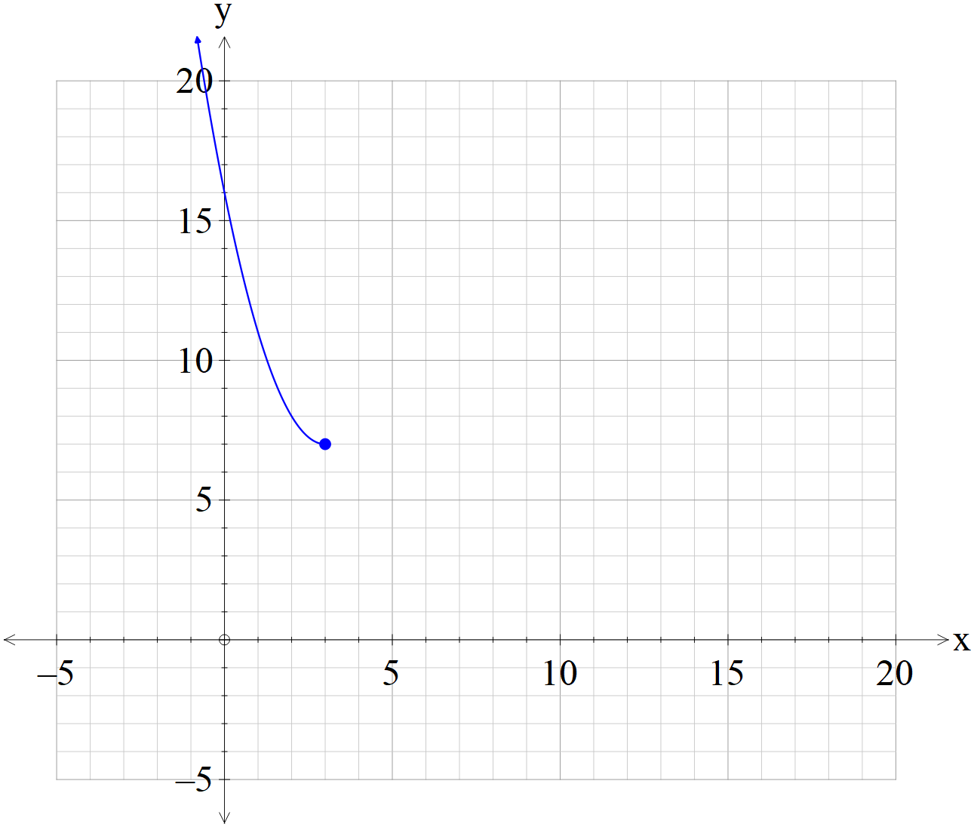

(a) Sketch the inverse function  on the axes above. (3 marks)

(b) Determine the rule for the inverse function and state the domain and range.

(4 marks)

**Question 5 (5 marks)**

Consider the graph of  which is graphed below.

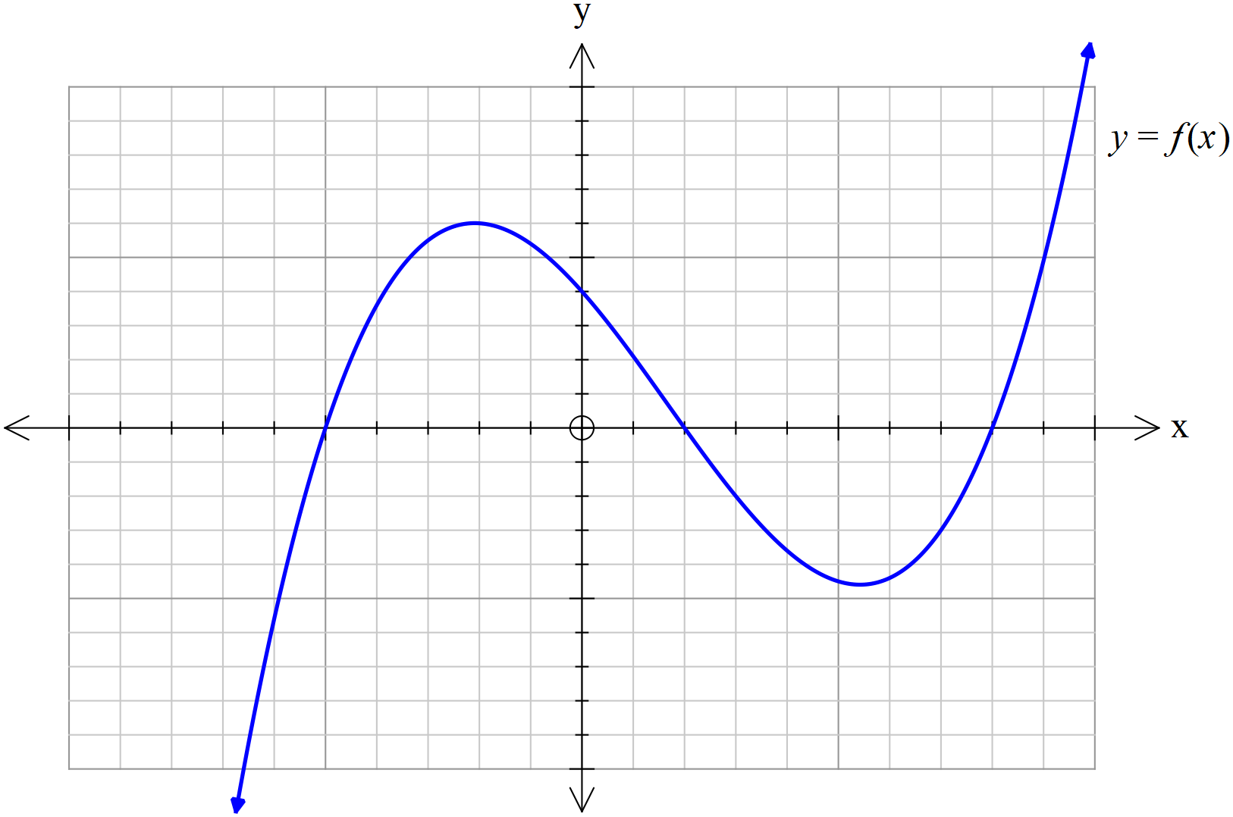

(a) On the axes below, sketch  (2 marks)

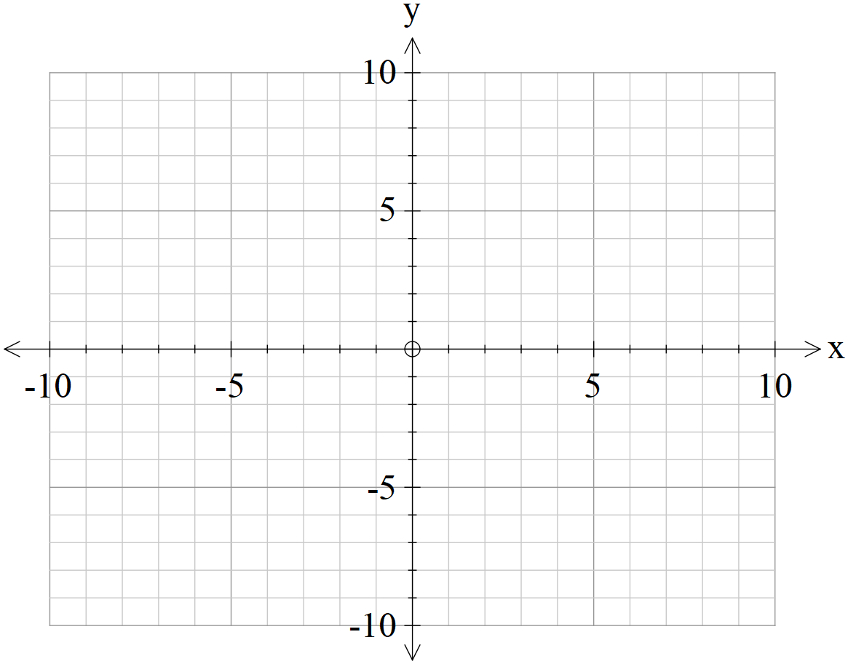

(b) On the axes below, sketch  (3 marks)



**Question 6 (6 marks)**

Sketch the graph of  on the axes below.



**Question 7 (5 marks)**

A triangular prism OACB is shown below with O as the origin and points A, B & C have respective position vectors  Point P lies on the line  in the ratio .

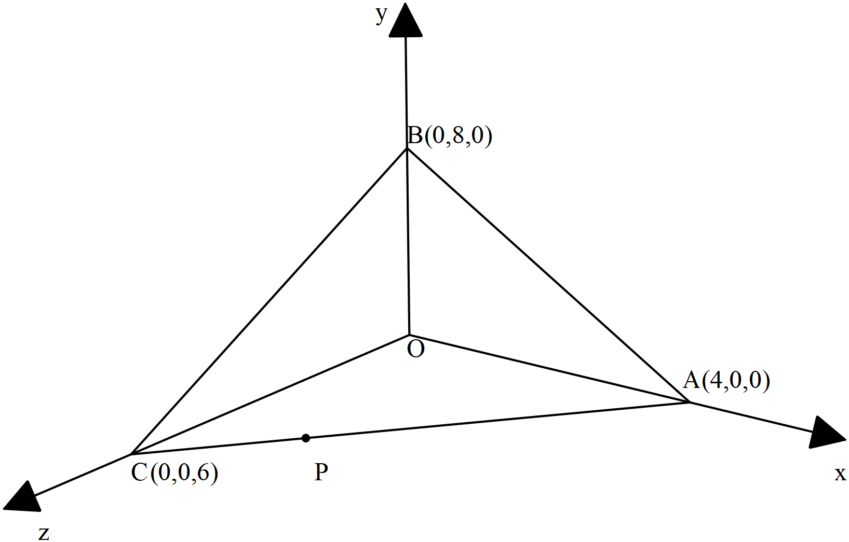

(a) Determine the vector equation of the line that passes through points 

( 2 marks)

(b) Determine the cartesian equation of the plane that contains points .

( 3 marks)

**Question 8 (5 marks)**

Consider a circle in the complex plane where the centre is given by  and a radius of 5 units. Let  be a point on this circle where  with  and 

(a) Determine  in exact cartesian form . ( 3 marks)

(b) Sketch this circle and point P in the complex plane below showing all major features.

( 2 marks)

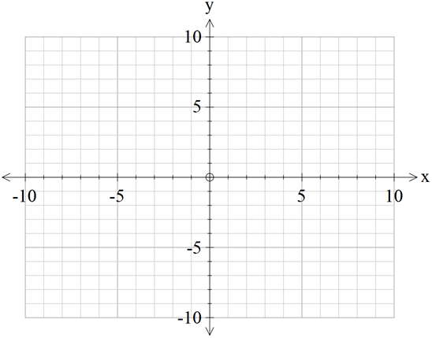

Re(z)

Im(z)

Additional working space

Question number:

Additional working space

Question number:

Additional working space

Question number:

Additional working space

Question number: